**Assignment 3**

**1. Define a base class person and a derived class employee with single inheritance.**

**-Define SetData() member functions in each of the class with different signatures to set the data**

**members and demonstrate overloading of member functions.**

**-Define GetData() member functions in each of the class with same signatures to display data and**

**demonstrate overriding of member functions.**

class Person{

int id;

String name;

int age;

String city;

public void setData(int id,String name,int age,String city){

this.id=id;

this.name=name;

this.age=age;

this.city=city;

}

public void getData()

{ System.out.println("Person Id:"+id+"\nPerson Name:"+name+"\nPerson Age:"+age+"\nPerson City:"+city);}

}

class Employee extends Person{

int sal;

public void setData(int id,String name,int age,String city,int sal){

this.id=id;

this.name=name;

this.age=age;

this.city=city;

this.sal=sal;

}

public void getData()

{ System.out.println("Employee Id:"+id+"\nEmployee Name:"+name+"\nEmployee Age:"+age+"\nEmployee City:"+city+"\nEmployee sal:"+sal);}

public static void main(String []args){

Person p=new Person();

System.out.println("Person class data");

System.out.println("################");

p.setData(101,"Swati",23,"Delhi");

p.getData();

System.out.println();

System.out.println("Employee class Data");

System.out.println("###################");

Employee e=new Employee();

e.setData(100,"Prachi",23,"Mumbai",200000);

e.getData();

}

}

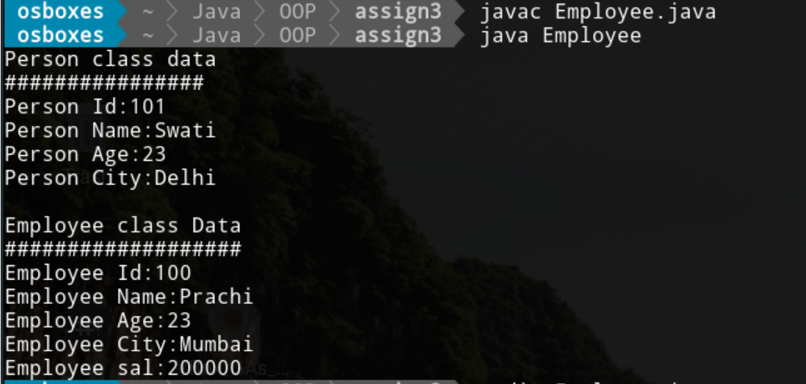

**2. Modify program 1 to define a parametrized constructor and finalizer in each class.**

**Demonstrate calling the constructor of the base class from the constructor of the derived class.**

**-Create objects of person and employee classes to show the order of invocation of constructors.**

class Person{

int id;

String name;

int age;

String city;

public Person(int id,String name,int age,String city){

this.id=id;

this.name=name;

this.age=age;

this.city=city;

}

public void display()

{ System.out.println("Person Id:"+id+"\nPerson Name:"+name+"\nPerson Age:"+age+"\nPerson City:"+city);}

}

class Employee1 extends Person{

int sal;

public Employee1(int id,String name,int age,String city,int sal){

super(id,name,age,city);

this.sal=sal;

}

public void display()

{ System.out.println("Employee Id:"+id+"\nEmployee Name:"+name+"\nEmployee Age:"+age+"\nEmployee City:"+city+"\nEmployee Salary:"+sal);}

public static void main(String []args){

Person p=new Person(100,"Swati",23,"Delhi");

System.out.println("Base class data");

System.out.println("################");

p.display();

System.out.println();

System.out.println("Derived class Data");

System.out.println("###################");

Employee1 e=new Employee1(102,"Prachi",23,"Delhi",20000);

e.display();

}

}

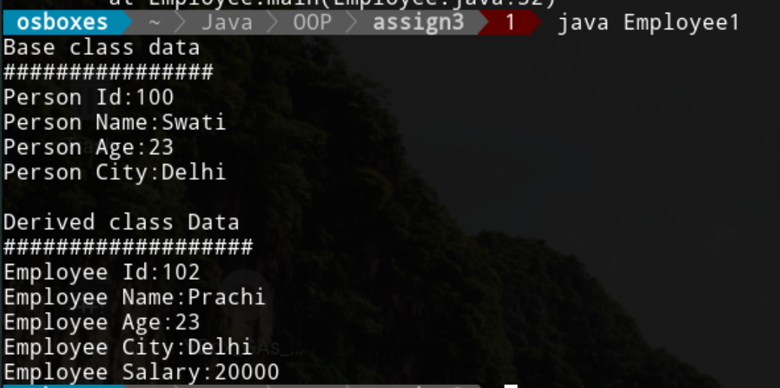

**3. Modify program 2 to define another class manager that derives from employee, to create a chain of multilevel**

**hierarchy.(manager inherits from employee & employee inherits from person)**

**-Create objects of person, employee, and manager classes to show the order of invocation of**

**constructors.**

class Person{

int id;

String name;

int age;

String city;

public Person(int id,String name,int age,String city){

this.id=id;

this.name=name;

this.age=age;

this.city=city;

}

public void display()

{ System.out.println("Person Id:"+id+"\nPerson Name:"+name+"\nPerson Age:"+age+"\nPerson City:"+city);}

}

class Employee extends Person{

int sal;

public Employee(int id,String name,int age,String city,int sal){

super(id,name,age,city);

this.sal=sal;

}

public void display()

{ System.out.println("Employee Id:"+id+"\nEmployee Name:"+name+"\nEmployee Age:"+age+"\nEmployee City:"+city+"\nEmployee Salary:"+sal);}

}

class Manager extends Employee{

int bonus=1000;

// bonus=sal+bonus;

public Manager(int id,String name,int age,String city,int sal,int bonus){

super(id,name,age,city,sal);

this.bonus=bonus;

}

public void display()

{ System.out.println("Manager Id:"+id+"\nManager Name:"+name+"\nManager Age:"+age+"\nManager City:"+city+"\nManager Salary:"+sal+"\nManager Bonus:"+bonus);}

public static void main(String []args){

Person p=new Person(100,"Swati",23,"Delhi");

System.out.println("Person class data");

System.out.println("################");

p.display();

System.out.println();

System.out.println("Employee class Data");

System.out.println("###################");

Employee e=new Employee(102,"Prachi",23,"Delhi",20000);

e.display();

System.out.println();

System.out.println("Manager Class Data");

System.out.println("##################");

Manager m=new Manager(1004,"Mahesh",45,"Gurugram",20000,21000);

m.display();

}

}

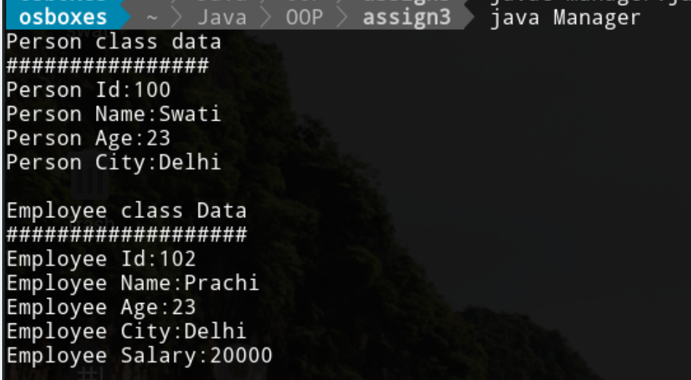

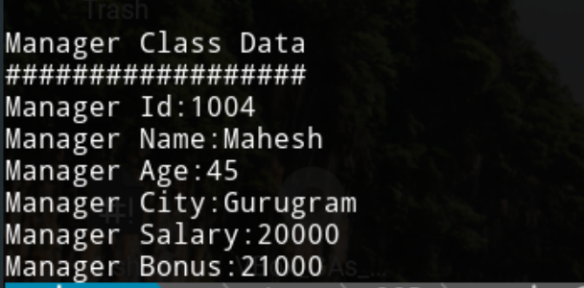

**4. Modify program 2 to define another class student that derives from person, to create a hierarchial**

**inheritance.(employee and student inherit from person)**

**-Create objects of person, employee, and student classes to show the order of invocation of**

**constructors.**

class Person{

int id;

String name;

int age;

String city;

public Person(int id,String name,int age,String city){

this.id=id;

this.name=name;

this.age=age;

this.city=city;

}

public void display()

{ System.out.println("Person Id:"+id+"\nPerson Name:"+name+"\nPerson Age:"+age+"\nPerson City:"+city);}

}

class Employee extends Person{

int sal;

public Employee(int id,String name,int age,String city,int sal){

super(id,name,age,city);

this.sal=sal;

}

public void display()

{ System.out.println("Employee Id:"+id+"\nEmployee Name:"+name+"\nEmployee Age:"+age+"\nEmployee City:"+city+"\nEmployee Salary:"+sal);}

}

class Student extends Person{

float percent;

public Student(int id,String name,int age,String city,float percent){

super(id,name,age,city);

this.percent=percent;

}

public void display()

{ System.out.println("Student Id:"+id+"\nStudent Name:"+name+"\nStudent Age:"+age+"\nStudent City:"+city+"\nStudent Percent:"+percent);}

public static void main(String []args){

Person p=new Person(100,"Swati",23,"Delhi");

System.out.println("Person Class data");

System.out.println("################");

p.display();

System.out.println();

System.out.println("Employee Class Data");

System.out.println("###################");

Employee e=new Employee(102,"Prachi",23,"Delhi",10000);

e.display();

System.out.println();

System.out.println("Student Class Data");

System.out.println("##################");

Student s=new Student(1004,"Mahesh",23,"Gurugram",90);

s.display();

}

}

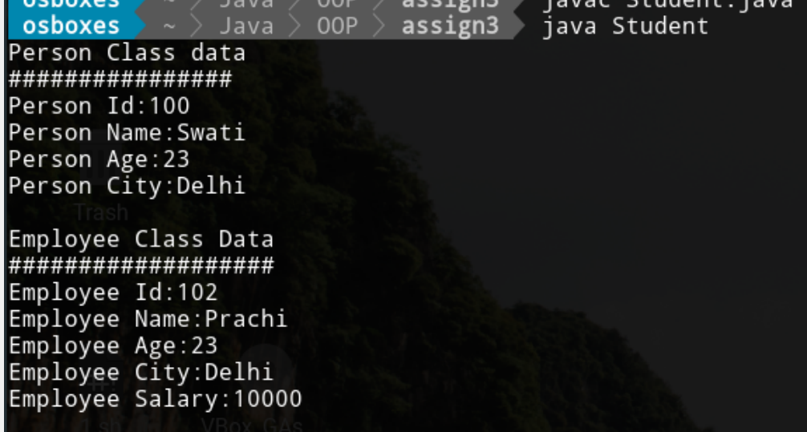

**5. Write a java file Person.java containing definition of independent class Person in package com.person,**

**and another java file Address.java containing definition of independent class Address in com.address**

**package.**

**-Write a container class employee that has a person and an address object as contained data**

**members (besides other data members) by importing the above packages.**

**-Demonstrate the passing of arguments in the constructors of person and address classes by the**

**constructor of the employee class.**

**//file Person.java**

package com.person;

public class Person{

int id;

int age;

String name;

String city;

public Person(int id,int age,String name,String city){

this.id=id;

this.age=age;

this.name=name;

this.city=city;

}

public void display(){

System.out.println("Person Detail");

System.out.println("##############");

System.out.println("Person Id:"+id+"\nPerson age:"+age+"\nPerson Name:"+name+"\nPerson City:"+city);

}

}

**//File Address.java**

package com.address;

public class Address{

int hno;

String street;

String city;

int pin;

public Address(int hno,String street,String city,int pin){

this.hno=hno;

this.street=street;

this.city=city;

this.pin=pin;

}

public void display(){

System.out.println("Address Detail");

System.out.println("###############");

System.out.println("H.No:"+hno+"\nStreet:"+street+"\nCity:"+city+"\nPincode:"+pin);

}

}

**//file Employee.java**

package mypack;

import com.address.Address;

import com.person.Person;

public class Employee{

int id;

int age;

String name;

Person p;

Address add;

Employee(int id,int age,String name,Person p,Address add)

{

this.id=id;

this.age=age;

this.name=name;

this.p=p;

this.add=add;

}

void display()

{

System.out.println("Employee Data:");

System.out.println("###############");

System.out.println("Employee Id:"+id+"\nEmployee Age:"+age+"\nEmployee Name:"+name);

System.out.println();

p.display();

System.out.println();

add.display();

}

public static void main(String[]args){

Person p=new Person(100,23,"Prachi","Delhi");

Address a=new Address(789,"SainVihar","Delhi",100200);

Employee e=new Employee(1002,23,"Komal",p,a);

e.display();

}

}

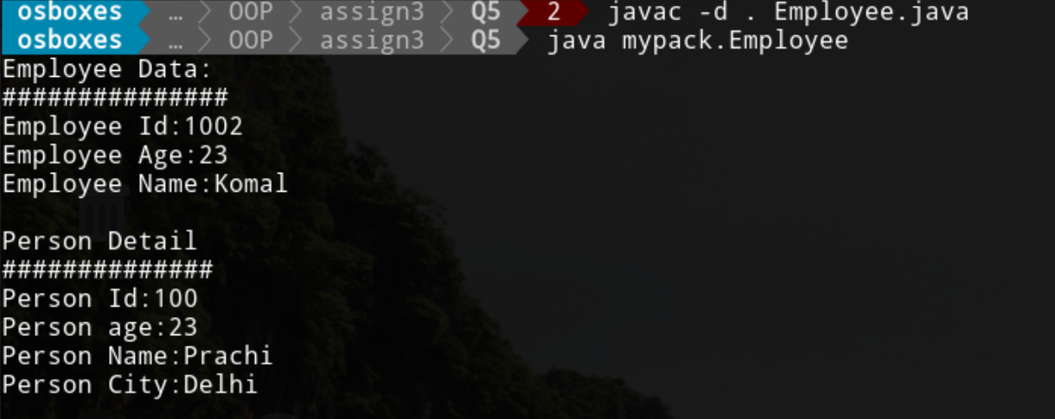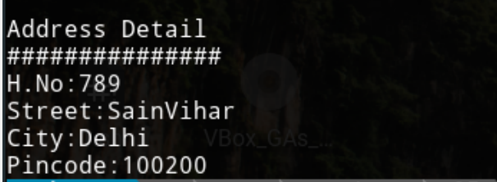

**6. Rework program 5 to use both inheritance and containership. The employee class inherits from person class and acts as a container class for address class object.**

**//File Address.java**

package com.address;

public class Address{

int hno;

String street;

String city;

int pin;

public Address(int hno,String street,String city,int pin){

this.hno=hno;

this.street=street;

this.city=city;

this.pin=pin;

}

public void display(){

System.out.println("Address Detail");

System.out.println("###############");

System.out.println("H.No:"+hno+"\nStreet:"+street+"\nCity:"+city+"\nPincode:"+pin);

}

}

**//File Employee.java**

package mypack;

import com.address.Address;

class Person{

int id;

int age;

String name;

Address add;

public Person(int id,int age,String name,Address add){

this.id=id;

this.age=age;

this.name=name;

this.add=add;

}

public void display(){

System.out.println("Person Detail");

System.out.println("##############");

System.out.println("Person Id:"+id+"\nPerson age:"+age+"\nPerson Name:"+name);

add.display();

}

public static void main(String []args){

Address a=new Address(789,"SainVihar","Delhi",100200);

Person p=new Person(100,23,"Prachi",a);

}

}

public class Employee extends Person{

int sal;

Employee(int id,int age,String name,Address add,int sal)

{

super(id,age,name,add);

this.sal=sal;

}

public void display()

{

System.out.println("Employee Data:");

System.out.println("###############");

System.out.println("Employee Id:"+id+"\nEmployee Age:"+age+"\nEmployee Name:"+name);

System.out.println();

add.display();

System.out.println("Employee Salary:"+sal);

}

public static void main(String[]args){

//Address a=new Address(789,"SainVihar","Delhi",100200);

//Person p=new Person(100,23,"Prachi",a);

Address a=new Address(789,"SainVihar","Delhi",100200);

Person p=new Person(100,23,"Prachi",a);

p.display();

System.out.println();

Employee e=new Employee(1002,23,"Komal",a,10000);

e.display();

}

}

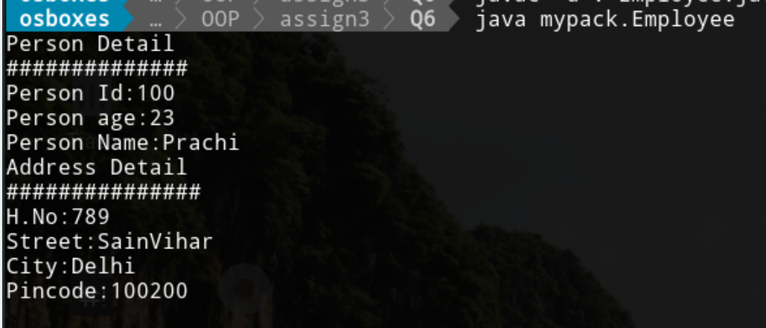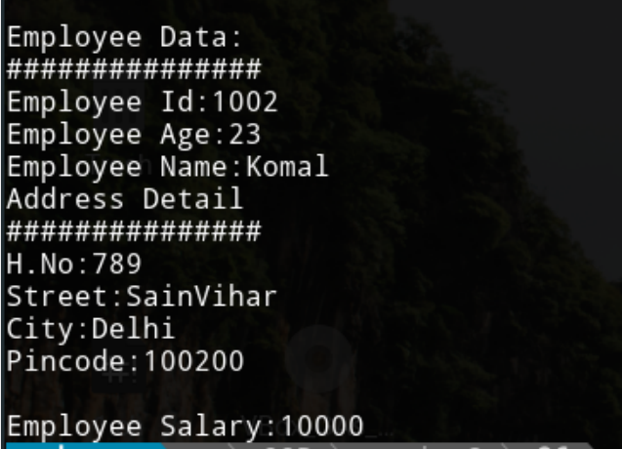

**7. Write a program to demonstrate the use of try, catch, finally throw and throws keywords and demonstrate the following points in the program.**

**a) Multiple catch blocks.**

public class MultiCatch {

public static void main(String[] args) {

try{

String s=null;

System.out.println(s.length());

}

catch(ArithmeticException e)

{

System.out.println("Arithmetic Exception occurs!!!\n");

}

catch(ArrayIndexOutOfBoundsException e)

{

System.out.println("ArrayIndexOutOfBounds Exception occurs!!!\n");

}

catch(NullPointerException e)

{

System.out.print("NullPointerException Occur!!!\n");

}

catch(Exception e)

{

System.out.println("Super class exception Occur!!!");

}

System.out.println("Execute the code!!!");

}

}

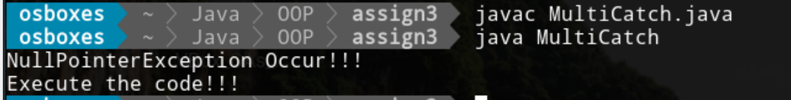

**b) try-catch-finally combination.**

class Combination {

public static void main (String args[]) {

//try block

try

{

int data = 125 / 0;

System.out.println ("Result:" + data);

}

//catch block

catch (Exception e) {

System.out.println (e);

}

//finally block

finally {

System.out.println ("I am in finally block!!!");

}

System.out.println ("Rest of the code...");

}

}

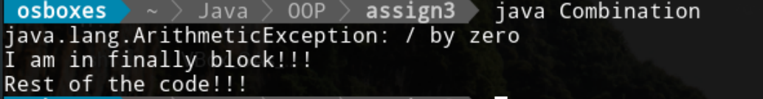

**c) try-finally combination.**

class Finally{

public static void main(String [] args){

try{

int num=70/0;

System.out.println(num);

}

finally{

System.out.println("Hello I am in Finally block!!!");

}

System.out.println("Hello I am out of block");

}

}

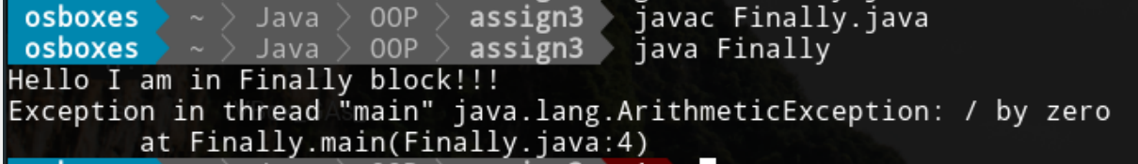

**d) Exception propagation among many methods.**

class Propagation{

public void division(int n1, int n2) {

System.out.println(n1/n2);

}

public void method1(int n1, int n2) {

//not caught here and hence propagate to method2.

division(n1,n2);

}

public void method2(int n1, int n2){

try{

method1(n1,n2);

}catch(ArithmeticException e){

System.out.println(e);

System.out.println("Exception Handled");

}

}

public static void main(String args[]){

Propagation p =new Propagation();

//method call

p.method2(20, 0);

}

}

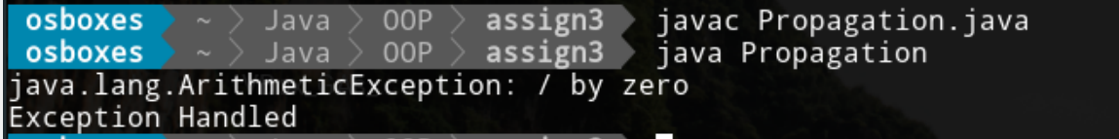**e) Use of getMessage(), printStackTrace() function of Throwable class.**

import java.io.*;

public class Throw {

public static void method() {

try

{

FileReader file = new FileReader("C:\\Users\\Prachi\\Desktop\\abc.txt");

BufferedReader fileInput = new BufferedReader(file);

throw new FileNotFoundException();

} catch (FileNotFoundException e)

{ System.out.println(e);

System.out.println("Output for getMessage() method :");

System.out.println("##############################");

e.getMessage();

System.out.println("Output for printStackTrace() method:");

}

System.out.println("Exception Handle Succesfully");

}

public static void main(String args[]){

method();

System.out.println("rest of the code...");

}

}

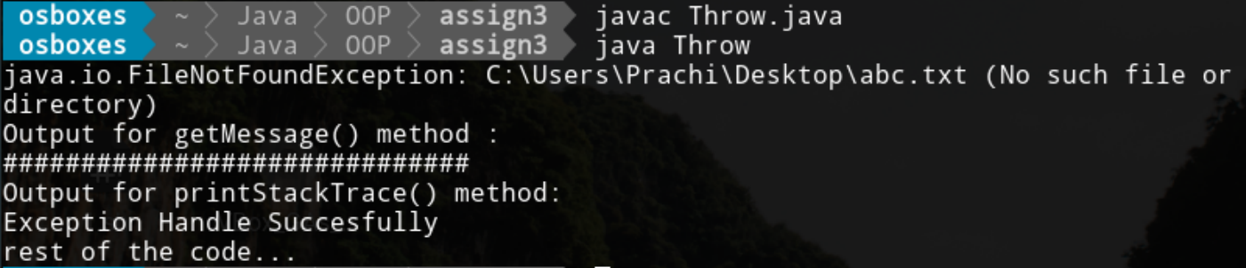

import java.io.*;

public class Throw {

public static void method() {

try

{

FileReader file = new FileReader("C:\\Users\\Prachi\\Desktop\\abc.txt");

BufferedReader fileInput = new BufferedReader(file);

throw new FileNotFoundException();

} catch (FileNotFoundException e)

{

System.out.println("Output for printStackTrace() method:");

System.out.println("###################################");

e.printStackTrace();

}

System.out.println("Exception Handle Succesfully");

}

public static void main(String args[]){

method();

System.out.println("rest of the code...");

}

}

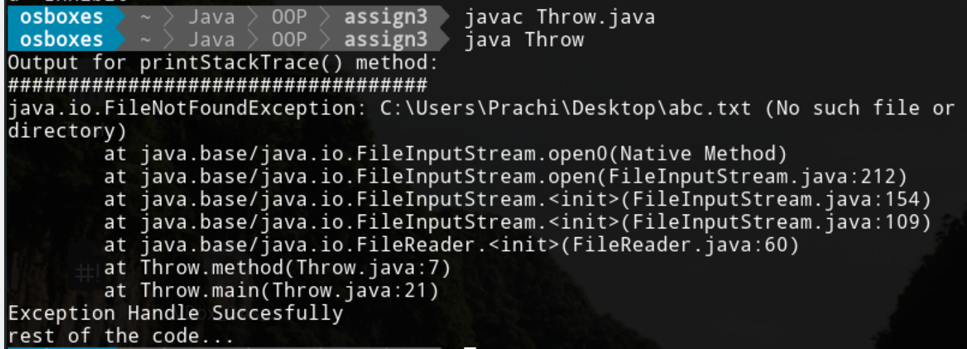

**f) Nested try blocks**

public class NestedTry{

public static void main(String args[]){

try{

//inner try block1

try{

int a =3/0;

}

//catch block of inner try block 1

catch(ArithmeticException e)

{

System.out.println(e);

}

//inner try block 2

try{

int a[]=new int[5];

a[5]=4;

}

//catch block of inner try block 2

catch(ArrayIndexOutOfBoundsException e)

{

System.out.println(e);

}

}

//catch block of outer try block

catch(Exception e)

{

System.out.println("handled the exception (outer catch)");

}

System.out.println("Hello I am out of nested try block");

}

}

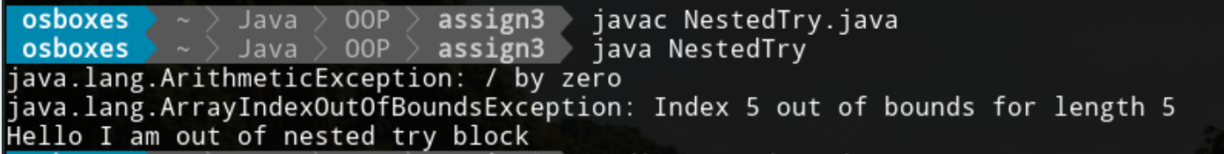

**8. Write a program to throw a checked exception explicitly using 'throw' keyword and**

**a) Handle the exception in same method.**

import java.io.*;

public class Throw {

public static void method() {

try

{

FileReader file = new FileReader("C:\\Users\\Prachi\\Desktop\\abc.txt");

BufferedReader fileInput = new BufferedReader(file);

throw new FileNotFoundException();

} catch (FileNotFoundException e)

{

System.out.println(e);

}

System.out.println("Exception Handle Succesfully");

}

public static void main(String args[]){

method();

System.out.println("Rest of the code!!!");

}

}

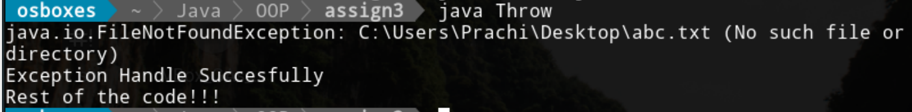

**b) use throws clause and handle the exception in some other method (calling method)**

import java.io.*;

class ThrowEx {

public static void findFile() throws IOException {

System.out.println("Rest of code in try block");

throw new IOException("File not found");

}

public static void main(String[] args) {

try {

findFile();

System.out.println("Rest of code in try block");

} catch (IOException e) {

System.out.println(e);

}

}

}

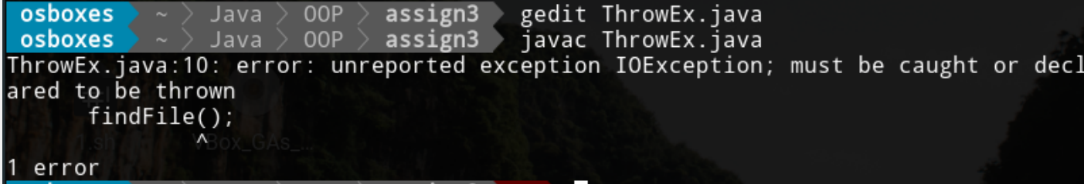

**c) Don't either handle or use the throws clause. Observe the result.**

import java.io.*;

class ThrowEx {

public static void findFile() throws IOException {

System.out.println("hello”);

}

public static void main(String[] args) {

findFile();

System.out.println("Rest of code in try block");

}

}

**.**

**9. Repeat program 8 with unchecked Exception and demonstrate the difference in both program.**

public class UncheckedException {

public static void main(String[] args)

{

int a[] = {1,2,3,4,5};

// Try block for exceptions

try {

System.out.println(a[5]);

} catch (ArrayIndexOutOfBoundsException e) {

System.out.println("Array out of index");

}

}

}



**b) Handle unchecked exception in other method or calling method.**

public class Unchecked {

static void ExceptionHandle(){

int a[] = {1,2,3,4,5};

// Try block for exceptions

try {

System.out.println(a[5]);

} catch (ArrayIndexOutOfBoundsException e) {

System.out.println(e);

System.out.println("Array out of index");

}

}

public static void main(String[] args)

{ ExceptionHandle();

}

}

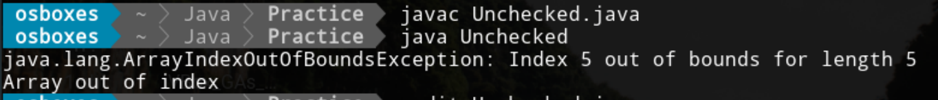

**c) Don't either handle or use the throws clause. Observe the result.**

public class Unchecked

{

public static void main(String args[])

{

//ArrayIndexOutOfBoundsException

int array[] = {1, 2, 3, 4, 5};

System.out.println(array[6]);

}

}

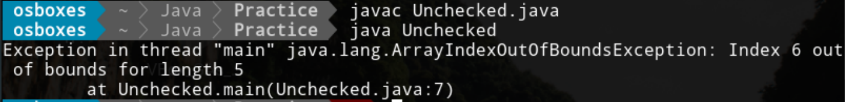

**Difference of checked and Unchecked Exception Program**

I observe that checked Exception is caught by compiler at the time of program compile not the run time of program

Unchecked Exception caught by Interpreter at the time of program execution.

**10. Create a user defined exception to check whether your employee exist in your data structure (use any data structure to store the employees -like array, ArrayList etc) and throw exception if name is not in the employees list. Use the catch and finally block to make an appropriate solution.**

import java.io.*;

import java.util.*;

public class Employee{

public static void main(String []args)throws IOException{

int i=0;

BufferedReader br=new BufferedReader(new InputStreamReader(System.in));

System.out.print("Enter The Employee Name:");

String name=br.readLine();

ArrayList<String> a = new ArrayList<>();

a.add("Prachi");

a.add("Rakesh");

a.add("Sapna");

a.add("Priya");

a.add("megha");

if (!a.contains(name)) {

try {

throw new NameNotFoundException(name);

} catch (NameNotFoundException e) {

System.out.println(e);

System.out.println("Sorry!!! Name is not found!!!");

}

finally{

br.close();

System.out.println("All resource are closed!!!");

}

}

else

{

System.out.println("Employee name is Found!!!");

}

}

}

**//file NameNotFoundException.java**

public class NameNotFoundException extends Exception{

public NameNotFoundException(String errorMsg)

{

super(errorMsg);

}

}

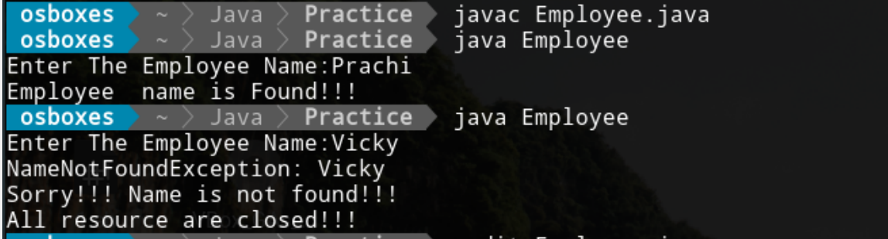

**11. Write a program to demonstrate the use of equals method of Object class and compare its functionality with ( = = ) operator.**

public class Equal {

public static void main(String[] args)

{

String s1 = "HELLO";

String s2 = "HELLO";

String s3 = new String("HELLO");

System.out.println("== operator used to compare address of objects");

System.out.println("####################################################");

System.out.println(s1 == s2);

System.out.println(s1 == s3);

System.out.println("equals() method used to compare contents of objects");

System.out.println("####################################################");

System.out.println(s1.equals(s2));

System.out.println(s1.equals(s3));

}

}

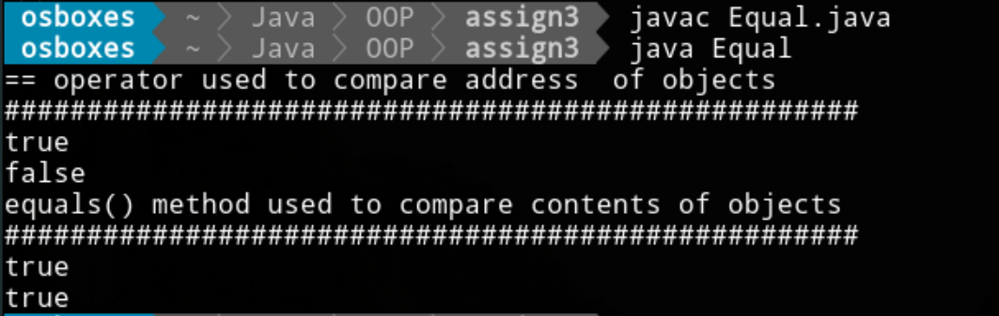

**Difference between == and equals() method.**

1 .equals() method is a method and == is operator.

2 .equals() method used for content comparison and == operators used for reference comparison (address comparison)

**12. Modify program 1 with Integer class Object. Use the override equals method of Integer with two different object wrapping same primitive int value ( like -10).demonstrate the difference in the output from program 11.**

import java.lang.*;

class Int{

public static void main(String[]args){

Integer a=new Integer(-10);

Integer b=new Integer(-10);

System.out.println("Compare content of object using equals() method");

System.out.println("################################################");

System.out.println(a.equals(b));

System.out.println(a.equals(b));

System.out.println(b.equals(a));

Integer c=new Integer(10);

System.out.println(c.equals(a));

System.out.println(c.equals(b));

System.out.println("Compare references of object using == operator");

System.out.println("##############################################");

System.out.println(a==b);

System.out.println(a==c);

}

}

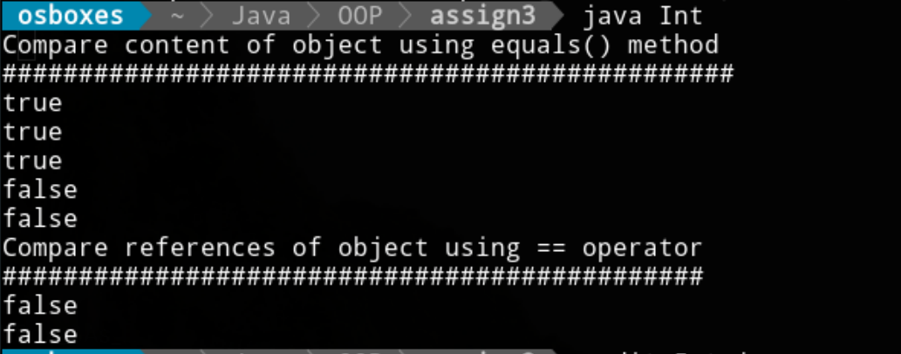

All wrapper class Objects are immutable.

- this equals() method override in the String class objects

so String class equal() method performed the content comparision

- The equals() method is a method of Integer class under java.lang package.

This method compares the value of the parameter to the value of the current Integer object.

It returns Boolean which corresponds to the equality of this Integer and method argument object.

It also overrides the equals() method of Object class.

**13. Demonstrate the use of ceil(), floor(), round(), random(), abs(), max(), min() methods of Math class.**

public class MathMethod {

public static void main(String args[]) {

int a = 20;

int b = -54;

double d1 = 84.6;

double d2 = 6.45;

//math.abs() method;

System.out.println();

System.out.println("abs() method");

System.out.println("############");

System.out.println("Absolute value of a:" + Math.abs(a));

System.out.println("Absolute value of b:" + Math.abs(b));

System.out.println("Absolute value of d1:" + Math.abs(d1));

System.out.println("Absolute value of d2:" + Math.abs(d2));

//math.round() method

System.out.println();

System.out.println("Round() method");

System.out.println("###############");

System.out.println("Round off for d1:"+Math.round(d1));

System.out.println("Round off for d2:"+Math.round(d2));

//math.ceil() and floor()method

System.out.println();

System.out.println("ceil() and floor()method");

System.out.println("#########################");

System.out.println("Ceiling of "+d1+"="+Math.ceil(d1));

System.out.println("Floor of "+d1+"="+ Math.floor(d1));

System.out.println("Ceiling of"+d2+"="+Math.ceil(d2));

System.out.println("Floor of"+d2+"="+Math.floor(d2));

//math.min() and math.max() method

System.out.println();

System.out.println("Minimum and Maximum method");

System.out.println("###########################");

System.out.println("Minimum out of"+a+" and "+b+"="+Math.min(a,b));

System.out.println("Maximum out of"+b+" and "+b+"="+Math.max(a,b));

System.out.println("Minimum out of"+d1+" and "+d2+"="+Math.min(d1,d2));

System.out.println("Maximum out of"+d1+" and "+d2+"="+Math.max(d1,d2));

//math.random() method

System.out.println();

System.out.println("Random() method");

System.out.println("################");

System.out.println("Random doubles:"+Math.random());

System.out.println("Random doubles:"+Math.random());

int c = (int)(Math.random()*(100));

System.out.println("Random() method on integer:"+c);

}

}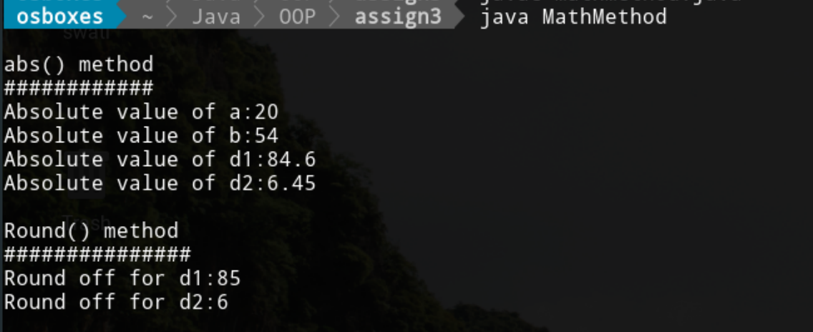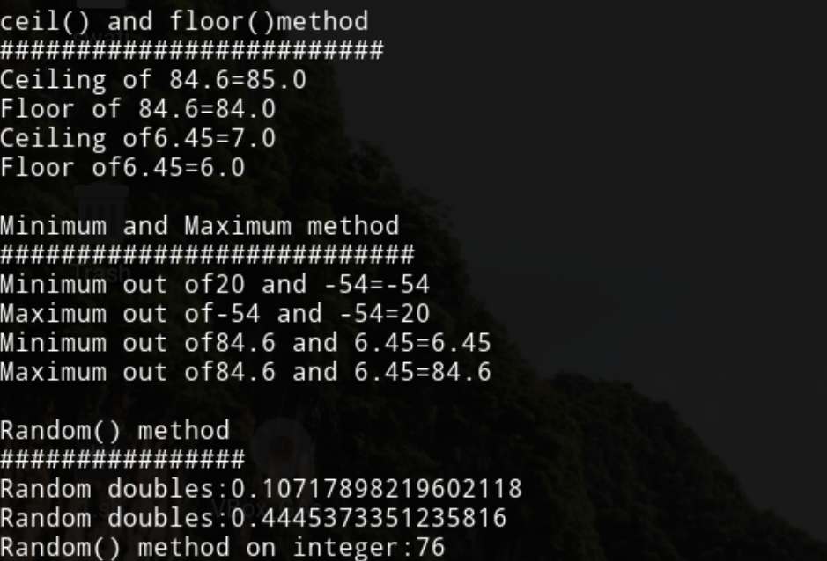

**14. Write a program to invoke garbage collector and show the details of free memory before and after the garbage collection.**

import java.util.*;

class Garbage

{

public static void main(String[] args)

{

Garbage g=new Garbage();

Runtime r=Runtime.getRuntime();

System.out.println("Total memory="+r.totalMemory());

System.out.println( "Free Memory before creating object ="+r.freeMemory());

for(int i=0;i<10;i++)

{

Date d=new Date();

d=null;

}

System.out.println("Free Memory After creating object ="+r.freeMemory());

r.gc();

System.out.println("Free Memory After calling gc ="+r.freeMemory());

}

}

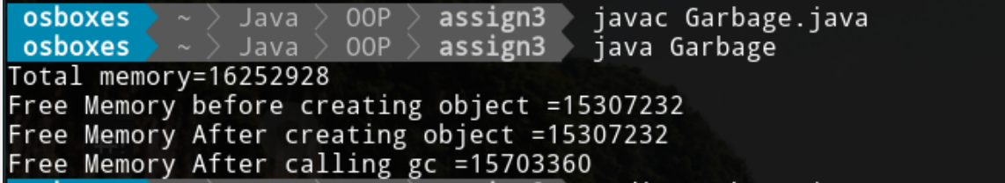

**15. Write a program to print all System properties using system class.**

import java.util.Properties;

public class PrintSystem{

public static void main(String[] args){

// List all System properties

Properties pros = System.getProperties();

pros.list(System.out);

}

}

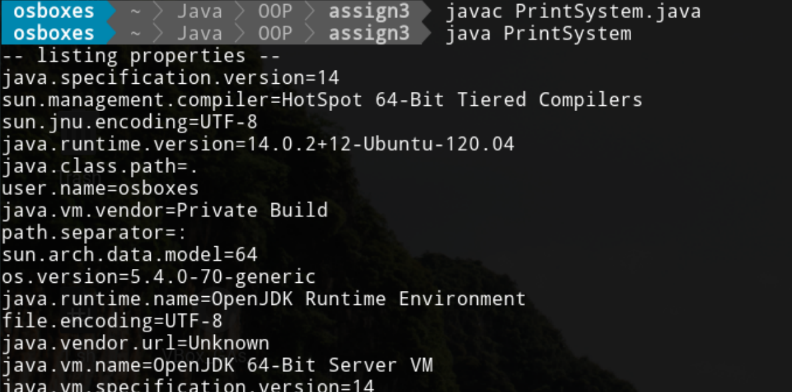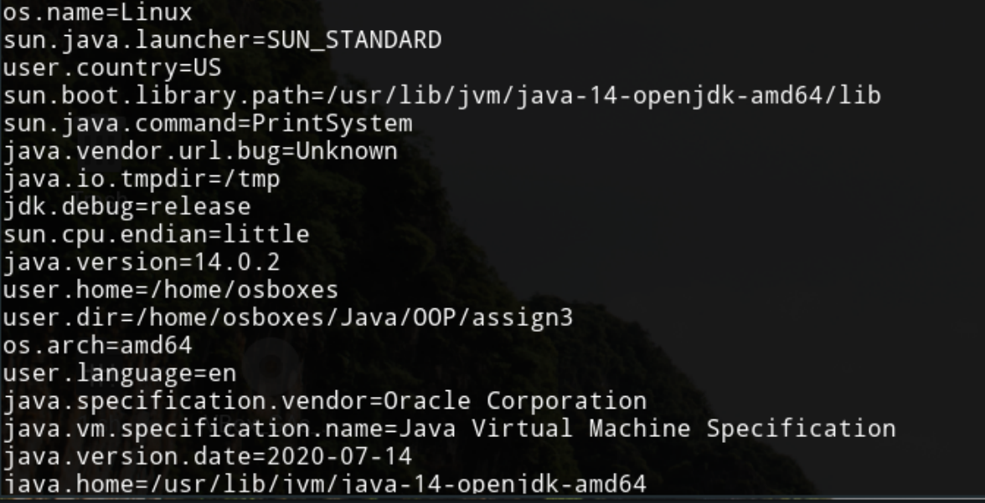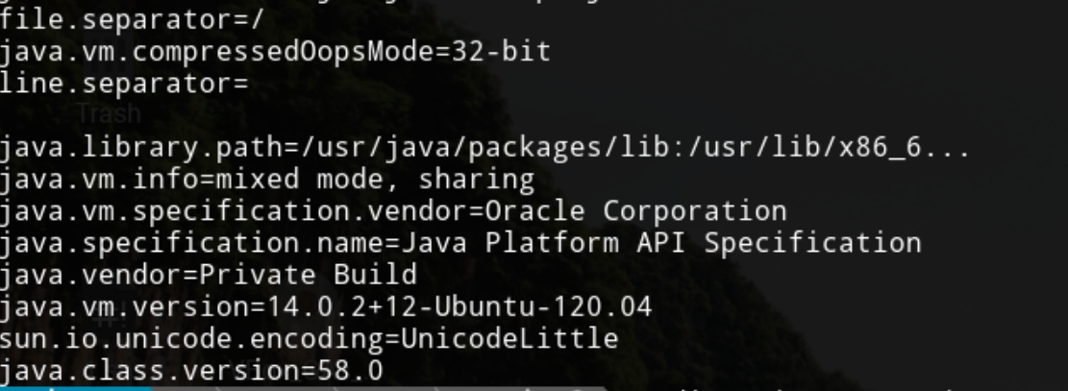

**16. Define a method setMyProperty (String, String) to set your own system property and use the same system property in another method**

import java.util.Properties;

class SetProperty{

public static void main(String [] args){

**//to set system property**

System.setProperty("java.home", "\\home\\Prachi");

System.setProperty("user.name", "Prachi");

System.setProperty("user.dir", "\\Java\\OOP");

**//to get property of system**

System.out.println("Get java home");

System.out.println("#############");

//System.out.println();

System.out.println(System.getProperty("java.home"));

System.out.println();

System.out.println("Get user name");

System.out.println("#############");

System.out.println(System.getProperty("user.name"));

System.out.println();

System.out.println("Get user Directory");

System.out.println("##################");

System.out.println(System.getProperty("user.dir"));

}

}

